

**Western Australian Certificate of Education**

**ATAR course examination, 2020**

**Question/Answer Booklet**

12 PHYSICS

Name

**Test 1 – Projectile and Circular Motion**

|  |  |  |  |  |  |  |  |  |  |  |
| --- | --- | --- | --- | --- | --- | --- | --- | --- | --- | --- |
| Student Number: In figures |  |  |  |  |  |  |  |  |  |  |

**Mark:**  In words

#### Time allowed for this paper

Reading time before commencing work: five minutes

Working time for paper: fifty minutes

**Materials required/recommended for this paper**

To be provided by the supervisor

This Question/Answer Booklet

Formulae and Data Booklet

***To be provided by the candidate***

Standard items: pens, (blue/black preferred), pencils (including coloured), sharpener, correction fluid/tape, eraser, ruler, highlighters

Special items: non-programmable calculators satisfying the conditions set by the School Curriculum and Standards Authority for this course

**Important note to candidates**

No other items may be taken into the examination room. It is your responsibility to ensure that you do not have any unauthorised notes or other items of a non-personal nature in the examination room. If you have any unauthorised material with you, hand it to the supervisor before reading any further.

**Structure of this paper**

|  |  |  |  |  |  |
| --- | --- | --- | --- | --- | --- |
| Section | Number of questions available | Number of questions to be answered | Suggested working time  (minutes) | Marks available | Percentage of exam |
| Section One:  Short Answers | - | - | - | - | - |
| Section Two:  Problem-solving | 5 | 5 | 50 | 34 | 100 |
| Section Three:  Comprehension | - | - | - | - | - |
|  |  |  |  | **Total** | 100 |

**Instructions to candidates**

1. The rules for the conduct of examinations at Holy Cross College are detailed in the College Examination Policy*.* Sitting this examination implies that you agree to abide by these rules.

2. Write your answers in this Question/Answer Booklet.

3. Working or reasoning should be clearly shown when calculating or estimating answers.

4. You must be careful to confine your responses to the specific questions asked and to follow any instructions that are specific to a particular question.

5. Spare pages are included at the end of this booklet. They can be used for planning your

responses and/or as additional space if required to continue an answer.

• Planning: If you use the spare pages for planning, indicate this clearly at the top of the page.

• Continuing an answer: If you need to use the space to continue an answer, indicate in the original answer space where the answer is continued, i.e. give the page number. Fill in the number of the question(is) that you are continuing to answer at the top of the page.

6. Answers to questions involving calculations should be ***evaluated and given in decimal***

***form*.** It is suggested that you quote all answers to ***three significant figures***, with the

exception of questions for which estimates are required. Despite an incorrect final result, credit may be obtained for method and working, providing these are ***clearly and legibly set out***.

7. Questions containing the instruction "estimate" may give insufficient numerical data for their solution. Students should provide appropriate figures to enable an approximate solution to be obtained. Give final answers to a maximum of two significant figures and include appropriate units where applicable.

8. Note that when an answer is a vector quantity, it must be given with magnitude and direction.

9. In all calculations, units must be consistent throughout your working.

1. Triathlon cyclists riding through the streets prefer path 2 to path 1 when turning around a corner at high speed.



Which of the following statements is the ***LEAST*** reasonable physical explanation for the cyclists' preference? Circle your choice. (1 mark)

(a) For the same frictional force, a cyclist on Path 2 can maintain a higher speed than a cyclist on Path 1.

(b) Path 1 has a smaller radius than path 2, resulting in a smaller centripetal force on the cyclist on Path 1.

(c) The cyclist on Path 1 has to decelerate and then accelerate much more than the cyclist on path 2, thus requiring more power.

(d) Path 2 is shorter than Path 1, so at the same speed a cyclist on Path 2 will take less time.

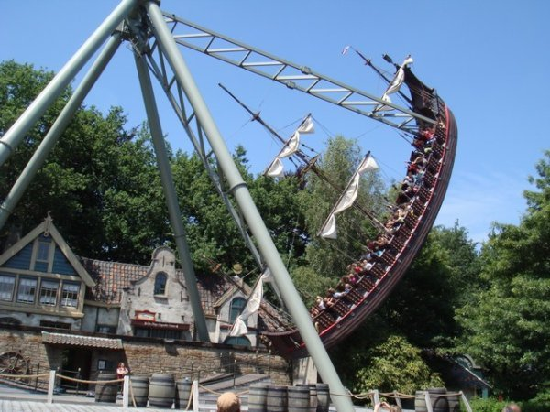2. Bounty's Revenge is a ride at the Adventure World fun park. Riders sit in a large `boat', that can swing like a pendulum suspended from a frame.

(a) When it swings freely (without friction or a driving force), what is the ***direction*** of the acceleration of a child sitting in the middle of the boat when he is at the highest and lowest points in his motion, P, Q and R? (1 mark)





(b) ***Estimate*** the apparent weight of a 75.0 kg person at point Q if the boat is moving at 7.50 ms-1. (5 marks)

3. In the picture below is a proposed roller coaster track. Each car will start from rest at point A and will roll with negligible friction.

What is the minimum safe value for the radius of curvature at point B so that the car does not leave the track? (5 marks)

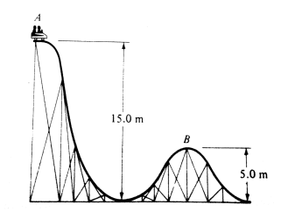

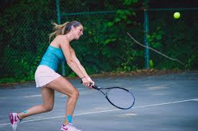4. A tennis player is forces to hit a defensive lob during a practice session. She plays the shot from 0.600 m above the court from a distance of 18.9 m from the opponent's baseline. The player hits the ball at 13.0 ms-1 at an angle of 55.0° to the horizontal.

(a) Assuming the opponent does not intercept the ball, does it land in court? Justify your answer with a calculation. (6 marks)

(b) Determine the impact velocity of the ball with the court, irrespective of where it lands.

(3 marks)

5. The diagram below shows a person holding a model aeroplane in horizontal circular motion by a light rope, which is at an angle of 35.0° to the horizontal.



(a) Draw the forces acting on the plane in the diagram above. (3 marks)

(b) If the tension in the rope is 22.0 N and the lift force perpendicular to the wings of the model aeroplane is 34.0 N, what centripetal force keeps the plane in circular motion?

(3 marks)

(c) Determine the mass of the plane? (3 marks)

(c) What will be the period of revolution of the model aeroplane if it moves in a circle with a radius of 15.0 m? (4 marks)